**A Project Report**

On

**PRODUCTION SUPERVISION AND EXECUTION**

**By**

**TANYA**

A202131421013

*Submitted to*

***Amity University Rajasthan***

***In partial fulfilment of the requirements for the degree of***

**Master of Science**

**in**

**Food Technology**

**Under the supervision of**

**Co-Guide**

Dr. Harish Kumar

Assistant Professor

Amity Institute of Biotechnology

Amity University Rajasthan

**Guide**

Mr. VPS Tyagi

HOD

Production-Infant Cereal



**AMITY INSTITUTE OF BIOTECHNOLOGY AMITY UNIVERSITY RAJASTHAN**

**NH-11C, Kant Kalwar, Jaipur- 303002**

**(2020-2022)**

**AMITY UNIVERSITY RAJASTHAN**

**ENDORSEMENT BY THE HEAD OF DEPARTMENT & PROGRAM COORDINATOR**

This is to certify that the dissertation entitled **“PRODUCTION SUPERVISION AND EXECUTION”** is a research/ project work carried by **TANYA** in partial fulfilment of the requirement for the degree of Master of Science in Food Technology under the guidance of **Dr. HARISH KUMAR.**

|  |  |
| --- | --- |
| **Prof. Vinay Sharma**  Director,  Amity Institute of Biotechnology,  Amity University Rajasthan | **Dr. Anuradha Saini**  Program Coordinator,  Amity Institute of Biotechnology,  Amity University Rajasthan |

Date: 5 July, 2023

Place: Jaipur

**CERTIFICATE BY THE GUIDE**

This is to certify that the project entitled **“PRODUCTION SUPERVISION AND EXECUTION”** is an original research/project work carried by **TANYA** in partial fulfilment of the requirement for the degree of Master of Science in Food Technology, during period from 26th January, 2022 to 26th July, 2023 under my direct supervision.

Mr. VPS Tyagi

HOD

Production-Infant Cereal

Date:

Place: Samalkha, Panipat

**CERTIFICATE BY THE CO-GUIDE**

This is to certify that the project entitled **“PRODUCTION SUPERVISION AND EXECUTION”** is an original research/project work carried by **TANYA** in partial fulfilment of the requirement for the degree of Master of Science in Food Technology, during period from 5th January, 2022 to 30th June 2022, under my co-supervision.

**Dr. Anuradha Saini**

Assistant Professor

Amity Institute of Biotechnology

Amity University Rajasthan

Date: 5 July, 2023

Place: Jaipur

**DECLARATION BY THE CANDIDATE**

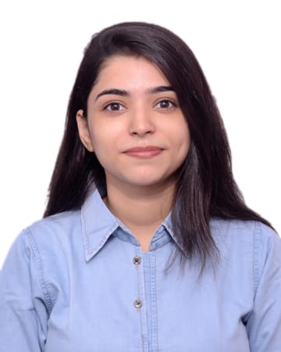

I hereby declare that this dissertation entitled **“PRODUCTION SUPERVISION AND EXECUTION”** is an original and genuine research/project work carried out by me.

Signature of the candidate

**TANYA**

Date: 05 July, 2022

Place: Jaipur

**COPYRIGHT DECLARATION BY THE CANDIDATE**

I hereby declare that the Amity University Rajasthan, Jaipur-303002, Rajasthan shall have the rights to preserve, use and disseminate the dissertation/Dissertation in print or electronic format for academic/ research purpose.

Signature of the candidate

**TANYA**

Date: 05 July, 2022

Place: Jaipur

**Amity University Rajasthan, Jaipur-303002, Rajasthan**

**ACKNOWLEDGEMENT**

My sincere sense of gratitude to everyone who helped in successful completion of my in-plant training. I take this opportunity to express gratitude and deep regards to Nestle India Ltd. to provide such an opportunity for this wonderful training experience.

My sincere gratitude towards **Mr. VPS Tyagi HOD- Production** and **Mr. Umesh Goel, Assistant Manager- Production**, who provided me with extreme guidance, mentorship and encouragement throughout the in-plant training. I am also very thankful to **Ms. Moksha Mathpal** for giving me this opportunity, as well as special thanks to all the company operators and workers who were quite helpful and friendly throughout the term. I would like to acknowledge all the Departmental Officers, Supervisors and Staff Members for providing me with actual training knowledge, for without their kind co-operation and help this training would not have been successful.

I am grateful and deeply indebted to our reverend **Vice chancellor Prof. Dr. Amit Jain** and **Dr. Vinay Sharma-Director (AIB)** and express my sincere thanks to them for providing with facilities and support for a great hands-on training.

My heartfelt gratitude to our mentor **Dr. Harish Kumar, Assistant Professor, Amity University Rajasthan**. I am thankful to all teaching and non-teaching staffs of Amity University Rajasthan for their extended help during the period.

Last but not the least, I would thank my colleagues who supported me throughout the term and my family for always supporting me and motivating me towards achieving my goals.

Signature of the candidate

**TANYA**

**PREFACE**

A concise understanding of the present business arena can only be obtained by the pragmatic application of hypothetical notions learned through academic activities and implementing them in the industrial setup and for improving practical knowledge and gaining experience, industrial training needs to be conducted. The actual goal of in-plant training is to learn about an industry's framework, methods, and internal dynamics.

The purpose of working in the plant was to learn about manufacturing basics, supervision and systematics involved in a real-life production unit. Good manufacturing and hygienic practices were also taught during the training process. This in-plant training gave a good quantity of practical information that made theoretical knowledge easier to grasp.

 I have made all attempts and conducted all essential research and analysis to deliver my thesis in an informative way in a reasonable timeframe. I have made a concerted effort to eradicate errors from the work. The report shall begin with an introduction of the work done during the training, replete with technical specifics. The generated results will then be discussed and examined.

The report also focuses on future efforts that might be considered to be a development of the existing work. I have done my best to keep the report brief while being technically correct. I'm hoping my attempt is successful.

|  |  |  |
| --- | --- | --- |
| **Sr. No.** | **Title** | **Page no.** |
| 1 |  |  |
|  |  |  |
|  |  |  |
|  |  |  |
|  |  |  |
|  |  |  |
|  |  |  |

**About the Organization**

**INTRODUCTION**

Nestlé was setup in year 1867 by Mr. Henry Nestlé, a Swiss citizen, with a motive to provide wholesome Infant dietetics, since there was high mortality rate among infants at that time. He had started with the inspiration of humanitarian ideology and with a strong will, a high degree of optimism and great ambition, transformed the mere business into a flourishing enterprise. Now Nestlé has made its place as the largest Food manufacturing company in the world, with worldwide ventures which include manufacturing and marketing of Condensed Milk, Powdered Milk, Ice Creams, other Dairy products, Infant foods, Chocolates and Confectionery items, Tea, Coffee, Culinary Products, Frozen Foods, Fruit Juices, Mineral Water and Pet foods, with recent venture into Cosmetics and Pharmaceuticals.

Nestlé is often quoted as “*The World Food Company,* as more than 98 % of the turnover comes from the countries other than the mother country, Switzerland. It has always taken a long-term view in the countries in which it operates, investing a lot in Research and Development and risk taking in new product areas. Today, Nestlé’s brand name “is associated with “Quality Products” in worldwide consumer market. We have promised consumers worldwide - “Good Food Good Life", which has become the emblem of the Company.

Nestle is present on all five continents.

**Nestlé’s Business strategic Pillars**

* Operational Efficiency – Low cost, Highly Efficient Operation
* Innovation & Renovation
* Product Availability – However, Whenever, Wherever
* Consumer Communication

**Basic Nestlé Leadership Principles**

* People and product oriented rather than systems oriented
* Committed to long-term shareholder value
* As decentralized as possible
* Continuous improvement

**NESTLE INDIA LTD.**

Nestle set up its operations in India, as a trading company in 1912 and began manufacturing products at Moga factory in 1962. The production started with the manufacturing of Milkmaid and other products were gradually brought to the fold. The product range, since then, has diversified so much and to such an extent that is really a tough task to enumerate all the products of the company on a single sheet of paper. After 28 Years of working under the name of Food Specialties Ltd., the company realized that in order to survive the international competition and to keep up with the changing time a better and closer relationship was required between Nestle International and its Indian counterpart. So, a unified production and marketing front, under the Nestle India Ltd. came into existence in 1990.

**NESTLE WORLDWIDE ORGANIZATION FLOWCHART**

**Nestle World**

**Chairman of the Board** Mr. Paul Bulcke

**Chief Executive Officer** Mr. Mark Schneider

**ASIA,** OCEANIA, AFRICA Region

AMERICA Region

EUROPE Region

**South Asia Region (SAR)**

Choladi (Tamil Nadu) - 1967

Bicholim (Goa) - 1997

Ponda (Goa) - 1995

Moga (Punjab) - 1961

**India**

Bangladesh

Sri Lanka

Tahliwal (Himachal Pradesh) - 2012

**Samalkha (Haryana) - 1992**

Nanjangud (Karnataka) - 1989

Pantnagar (Uttrakhand) - 2006

**Nestle India Product Range**

* Milk & Milk Products
* Infant Milk Formulae
* Health, Care & Nutrition Products
* Weaning Cereals
* Culinary Products
* Chocolates & Confectionery
* Instant Coffee
* Health Beverages

**NESTLE SAMALKHA FACTORY**

**INTRODUCTION**

Nestlé Samalkha was set up in year 1992, with Soya based products. Slowly it involved into manufacturing of Milk powders, Infant weaning Cereals, Culinary products, Chilled Dairy. Now Nestle Samalkha factory is actively engaged in manufacturing of variety of dairy and food products viz. Cereal Foods, Infant Foods and Dahi etc under different brand nam es and marketed in India.

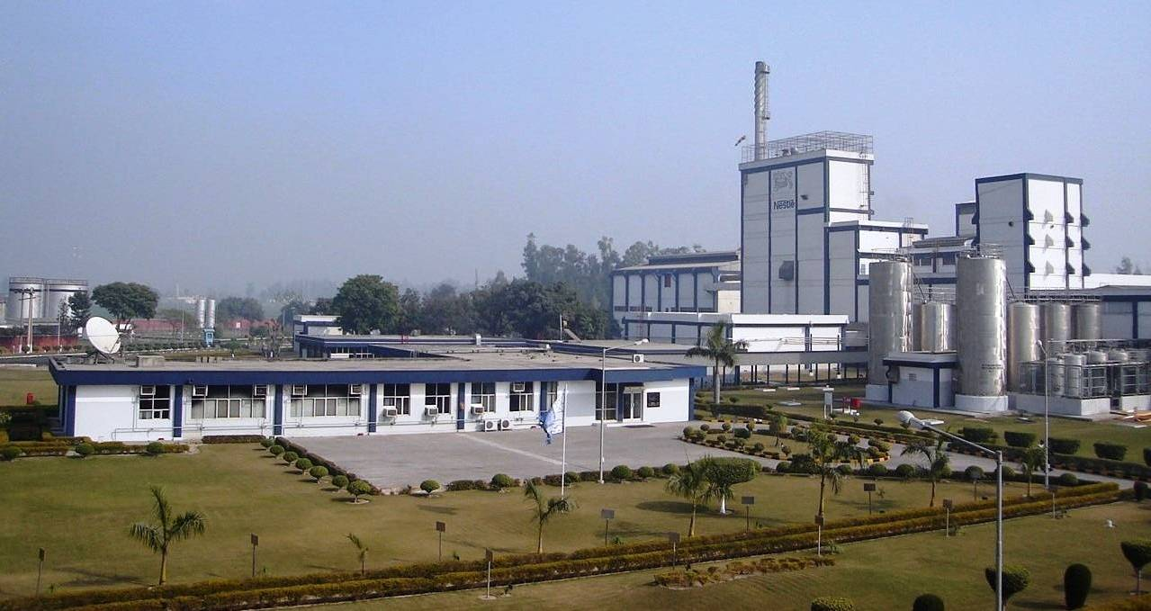

Nestle Samalkha operations are aimed at offering consumers with superior quality products and full value for his money. At the factory, all work towards achieving “excellence” through people and continuous improvement. With the business concept in place, Nestle has under its umbrella – the 5S, DMAIC, SAP, Hygiene/Pest control, Safety, NGMP, NIMS, Sensory evaluation and Training & Development vis-à-vis competition. Nestle have an overall edge on quality front viz., “Superior Quality Product”. Beginning with source of raw material till the dispatch of finished goods and later up to handling consumer response, Nestle adhere to strict quality norms as par with any international standards and products. On the environmental management front, Nestle has the best monitoring systems and NEMS in place. Nestle also follow an “Integrated Pest Management System” within and outside Nestle premises.

On the technological front, Nestle have the best of machinery, men, and technologies backed with Nested support. Nestle would like to emphasise that it is this superiority in “Quality” that makes Nestle stand apart and face brisk competition at the market place.

**GEOGRAPHICAL LOCATION**

Nestle Samalkha Factory is just besides railway track (New Delhi-Ambala Route) and 2 km away from G.T. Road towards left (New Delhi-Ambala) 70 km North to Delhi. Factory is 3.4 km away from main town i.e., Samalkha. Nestlé Samalkha Factory is at an angle of 45 left to true North.

**It has sound quality policy which is as follows:**

1. **Consumer Trust & Preference:** Consumer confidence and satisfaction in all our Brands, products and services
2. **Zero-Defect, Zero-Waste Attitude:** We always strive for excellence and no-waste in everything we do.
3. **Food Safety & Full Compliance**: We never compromise with food safety and always comply with all applicable regulatory requirements.
4. **Everybody’s Commitment:** Quality is a Group-wide objective

**NESTLÉ SAMALKHA PRODUCT RANGE**

**INFANT CEREAL**

**Cerelac & its variants**

**Pack Size**

200 gms, 350 gm

375 gms

Cerelac Apple 300g

Cerelac Apple Cherry 300g

Cerelac Ragi Apple 300g

Ceregrow Multigrain Cereal 300g

With Milk & Fruits

Cerelac Rice 300g

Cerelac Rice Veg 300g

Cerelac Veg 300g

Cerelac Khichdi with 300g

Veg and Ghee

Cerelac Wheat Mango 300g

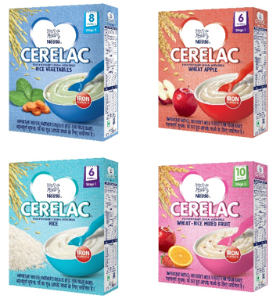

**Nestum & its variants**

Nestum Rice 300 g

Nestum Rice Veg 300 g

Nestum Rice Fruit 300 g

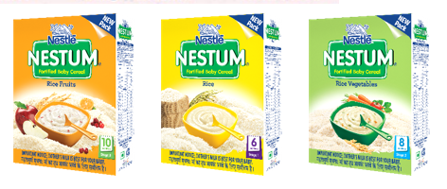

**INFANT FORMULA**

**Nestogen & its variants**

Nestogen 1 400 g

Nestogen 2 400 g

**Lactogen & its variants**

Lactogen 1 400 g

Lactogen 2 400 g

Lactogen 3 400 g

Lactogen 4 400 g

**NAN & its variants**

Nan Pro1 400 g

Nan Pro2 400 g

Nan Pro3 400 g

Nan Pro4 400 g

Pre Nan 400 g

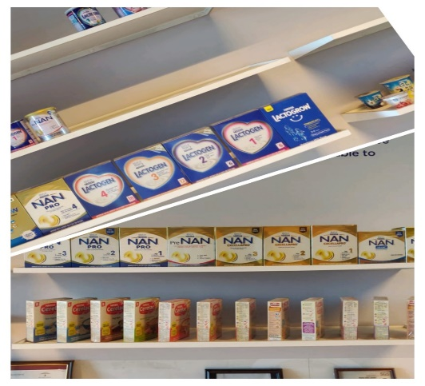

**CHILLED DAIRY**

* **Slim Dahi** 200 g, 400 g
* **Jeera Raita** 185 g, 380 g
* **Pouch curd** 85 g
* **A+ Dahi** 200 g, 400 g
* **Acti plus Probiotic Dahi** 400 g
* **Yoghurt & its variants**
* **Real Strawberry yoghurt** 100 g
* **Real Mango yoghurt** 100 g

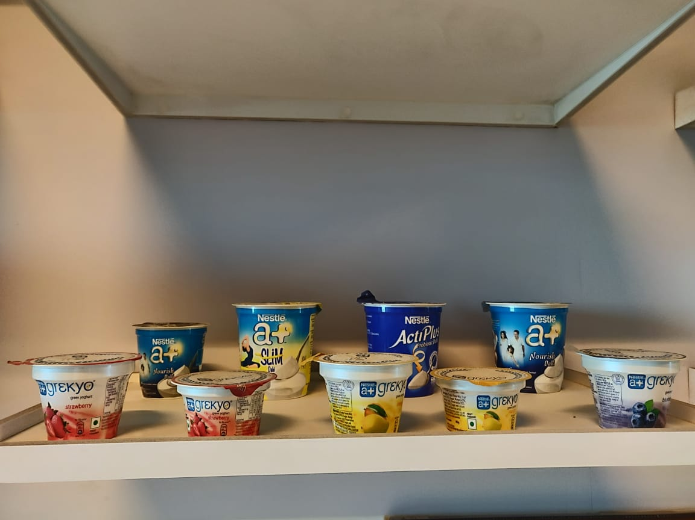

**Departments in Nestle Samalkha**

1. Production
2. Application Group
3. Agricultural services
4. Quality Assurance
5. Administration & Accounts
6. Engineering
7. Human Resources
8. Supply chain
9. Industrial Performance

I was allotted the Infant Cereals Production Department, hence would be talking about the same elaborately in my further report.

**INFANT CEREALS**

Developed by Henri Nestlé to reduce infant mortality in the 1860s, he invented Infant Cereals using existing nutritional science and technology. The first product was called Farine Lactée and is believed to have saved the life of premature baby boy named Wanner. By 1874, these infant cereals were sold in 18 countries. In the same year, vitamins were added. By 1948, they were marketed across the world. The brand was first registered in 1949. It contains most of the growth nutrition that is necessary for the baby at all development phases from 6 months onwards. It also has iron and essential minerals as Calcium, Vitamin D, protein, Zinc, Vitamin A, Vitamin C, Omega 3 and Omega 6, along with 18 important nutrients.

The Infant cereal is promoted for infants 6 months and older as a supplement to breast milk when it is no longer the sole item in an infant's diet. Infant cereal is not a substitute for breast milk and it is advised to continue breast feeding or infant formula along with Infant cereal. It can help babies develop tastes for other food as they are weaned from breast milk.

Cerelac baby cereals are available in 5 stages: -

Stage 1 (6 months+):

* Gentle baby food: Introductory solid food that is smooth & gentle on the stomach

Stage 2 (8 months+):

* Different tastes & textures: Addition of new tastes & textures that aid in the development of an infant’s taste buds

Stage 3 (10 months+):

* Enhanced taste & texture: Introduction of more fruits & vegetables to help a child appreciate complex tastes & textures

Stage 4 (12 months+):

* Strong foundation: Added multiple grains, fruits & vegetables to help a baby’s smooth transition to adult food

Stage 5 (18-24 months)

* Textured food: Different crunchies in different shapes. Whole grains with the goodness of cereals   
  & 19 important nutrients including vitamins and minerals.

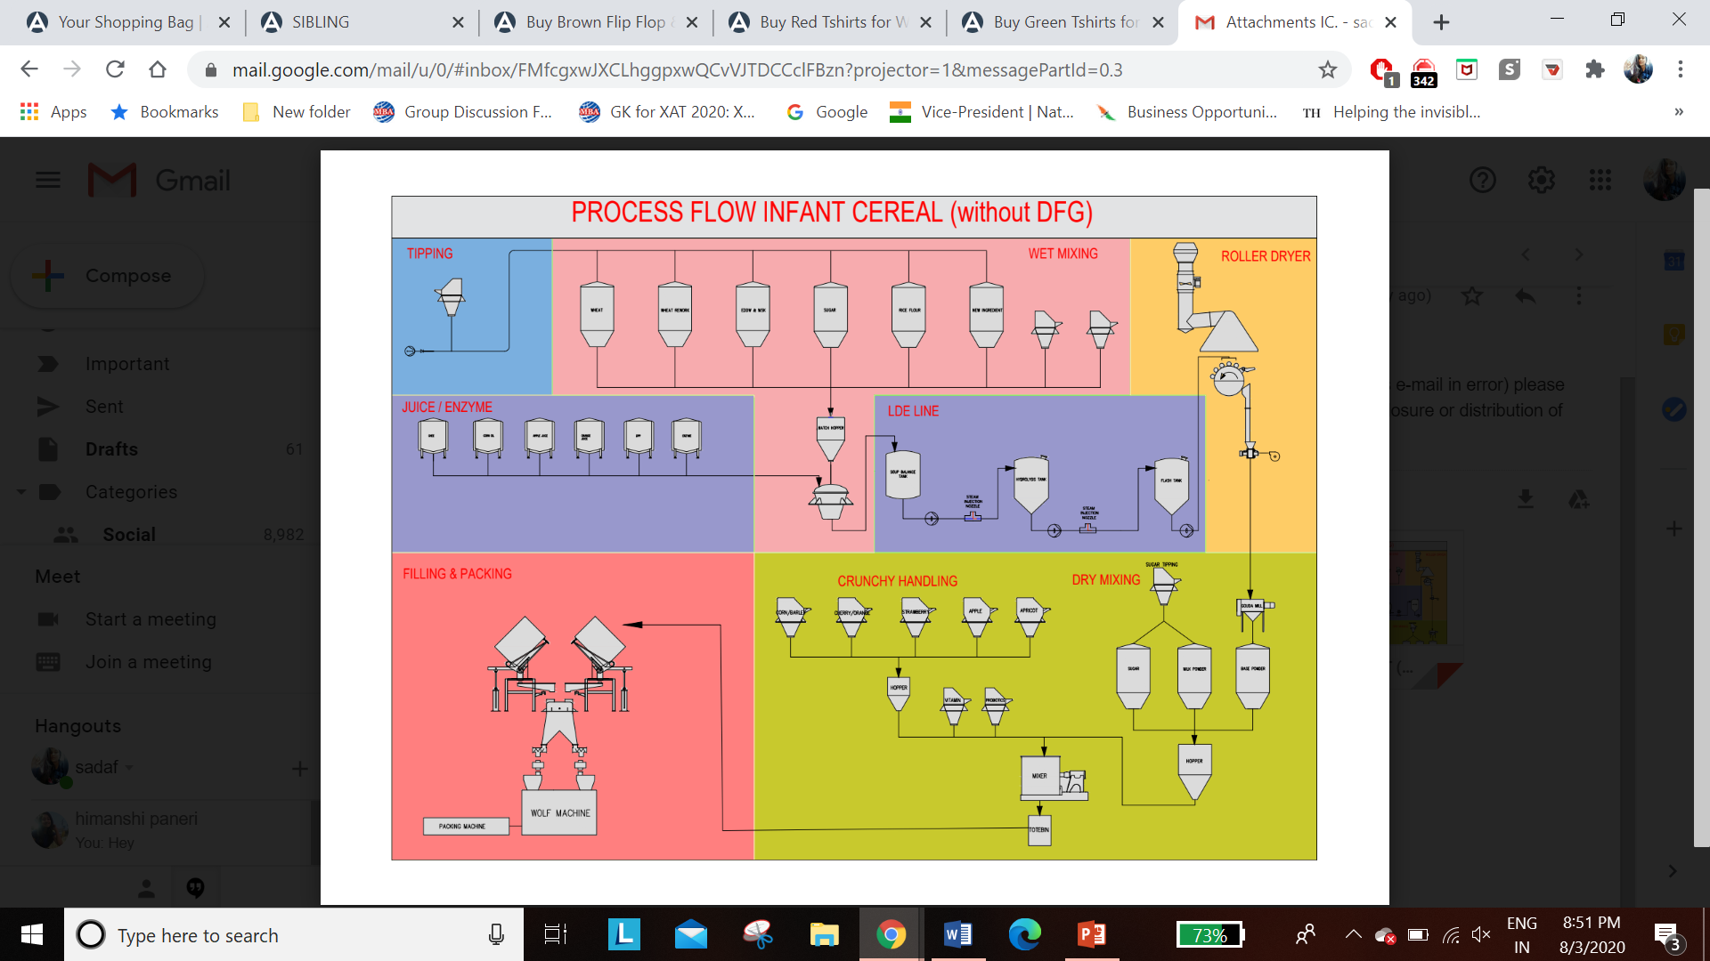

**Section Wise Description of Infant Cereal Plant**

**Cereal tipping**

The raw material tipped from this section is transferred to the Wet mix tower for further processing. Bags of raw material is transferred to the hopper using conveyer where they are cut, opened, and then emptied into hopper. It is then transferred into the silos in wet mix section using air blowing system.

Screw conveyer is provided to move raw material to vibratory sifter and finally into the hopper.

**Quality monitoring scheme checks**

|  |  |  |  |  |
| --- | --- | --- | --- | --- |
| QMS Check |  |  |  |  |
| Vibratory sieve intactness | Once per shift | Visual check | Intact/ broken |  |
| Magnet check | Once per shift | Visual check | Normal/ abnormal/ alarming |  |
| Oversize check | Once per shift | Checked using offline vibratory sieve | Normal/ abnormal |  |

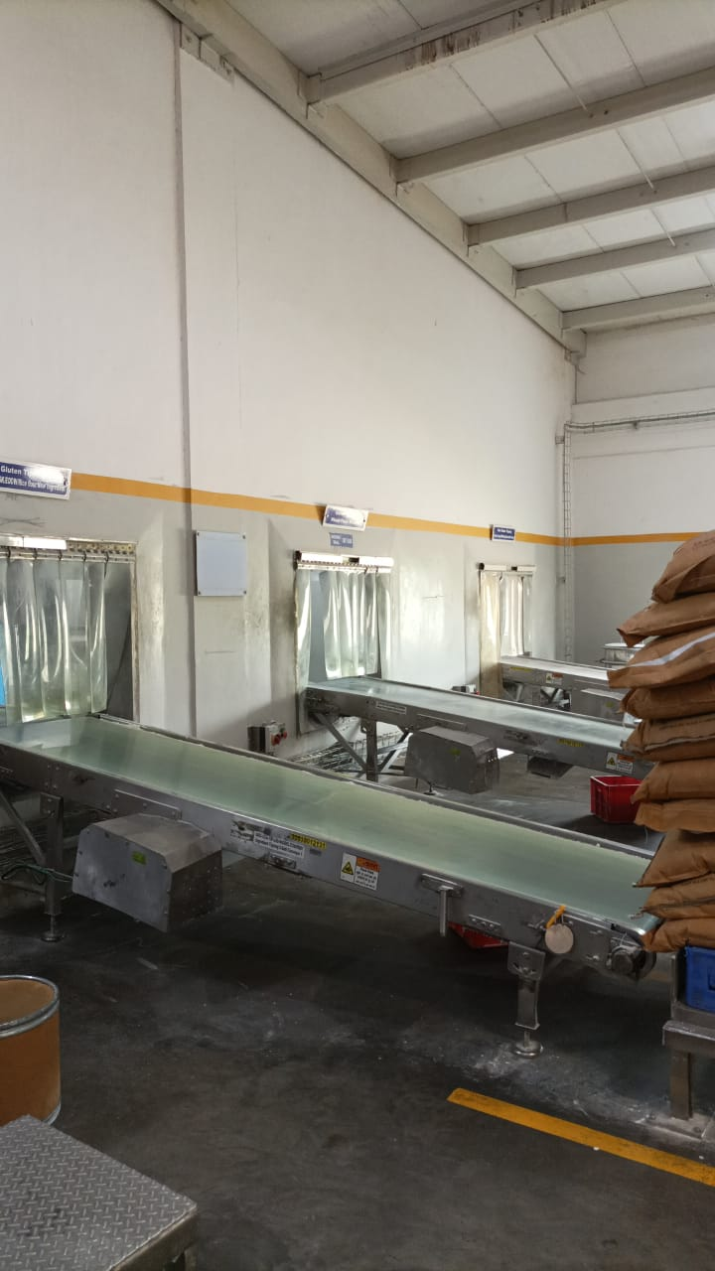

**Milk powder dumping**

The process flow is exactly similar to that of the cereal tipping. The only difference is the final destination of the material. The material from the MP dumping is transferred to the dry mix section where it is directly mixed with final base powder. Conditions of MP dumping is controlled with the help of AHU. Positive pressure is maintained in MP dumping area to avoid entry of flies. RH and temperature of room is also controlled. Temperature of room is kept below 25°C and RH is kept at 15%.

|  |  |  |  |  |
| --- | --- | --- | --- | --- |
| QMS Check |  |  |  |  |
| Vibratory sieve intactness | Once per shift | Visual check | Intact/ broken |  |
| Magnet check | Once per shift | Visual check | Normal/ abnormal/ alarming |  |
| Oversize check | Once per shift | Checked using offline vibratory sieve | Normal/ abnormal |  |

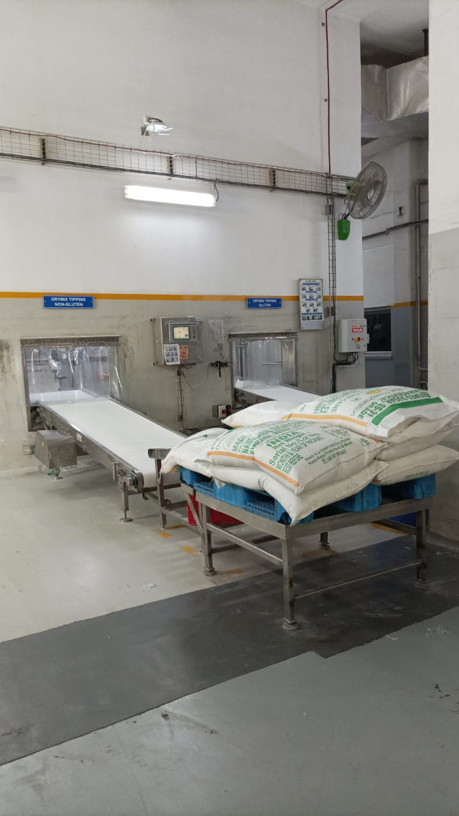

General Points :-

* Material from cereal tipping is transferred to wet mix tower and material from MP dumping is transferred to dry mix tower.
* Interlock at pressure of 0.5 bar is provided to avoid tripping of motor.
* When pressure exceed 0.5 Bar speed of conveyer is decreased to avoid tripping of air blower.
* 2 Personnel required to operate both conveyers of MP Dumping.
* 4 personnel are required to operate 3 conveyer of cereal tipping.
* Direction of rotation of star valve and screw conveyer is checked once per shift.
* Cartridge filter is provided to avoid loss of fine particles.
* Pressure difference in cartridge filter is 6 inches of water.

**Wet mix section**

The silos of different capacity store the raw material like flour, sugar rework, and calcium which is tipped to the scale hopper via screw conveyor. The material is then transferred into the batch hopper in the required amount as per the recipe. The calcium is tipped using the LIWF (loss in weight feeder) so as to monitor even the smallest deviation in the quantity of the material being tipped.

The liquid ingredients such as the oil, enzyme and the fruit juices are transferred to the papenmier along with the water and then all the dry RM is added to it where it is agitated for 60 seconds at 20-40 RPM.

This forms a soup which is transferred to the soup balance tank following which the quality monitoring check are done.

From the soup balance tank, the soup is then transferred to the ring layer mixer where steam is injected in the soup to activate the enzyme for hydrolysis* and gelatinization*. The temperature of the steam used is not more than 85 C and it is mixed at 1800RPM. It is then transferred to the hydrolysis tank.

After hydrolysis the steam is again injected into the soup to cease the enzyme activity and sterilization process.

The process is continued by transferring the cooked soup into the flash tank where the vapors are released so as to maintain the pressure and the soup is cooled before it is transferred to the roller dryer.

*Hydrolysis:-

Hydrolysis of starch is carried out by using alpha amylase enzyme. Hydrolysis is carried out to provide high calorie easily digestible food for babies. In this process starch is broke down into simple sugars, which increase its sweetness as well as glycemic index. Hydrolysis is carried out to adjust the viscosity of pap. Temperature required for hydrolysis is 70°C.

Due to efficiency reasons temperature of DSI-1 is set at 80°C, temperature of 86°C is maintained to avoid effects of temperature fluctuations.

During hydrolysis, complete hydrolysis of starch does not occur partial hydrolysis of starch occurs which lead production Low Dextrose equivalence.

*Gelatinization :-

Amount of amylose and amylopectin present in starch depend on the type of starch and its source. Amylose (4000D) is straight chain polymer connected with α-1, 4-glycosidic linkages; amylose is a straight chain polysaccharide. Amylose (10,000) is a branched chain polysaccharide with straight linkages at α-1, 4 position while branching occurs at α-1,6 position. When the temperature of soup is increased to 75°C gelatinization of starch starts occurring. During gelatinization, water is absorbed into starch it starts swelling and intermolecular bonds breaks, which lead to the breakage of crystalline structure. During gelatinization, starch loses its crystallinity and it starts to become more amorphous. Amorphous starch is readily attacked by enzymes making it easily digestible. Gelatinized starch is more viscous.

**Direct steam injection (DSI):**

|  |  |
| --- | --- |
| DSI | Purpose |
| DSI-1 | Achieve temp for hydrolysis |
| DSI-2(G)  (NG) | 1. Deactivate enzyme 2. Destroy pathogenic organism |

* Non-return valve is provided to avoid the entry of soup in pipeline.
* Back pressure valve is provided to avoid flashing of steam
* DSI-2 is provided with two RTD to measure

**Key Learning:-**

|  |  |  |
| --- | --- | --- |
| More Enzyme | More Hydrolysis | Thin pap |
| Less Enzyme | Less Hydrolysis | Thick pap |
| More Water | Porous Film | Density Less |
| Less Water | Less porous Film | Density More |
| More Soup TS | Less Porous Film | Density More |
| Less Soup TS | More Porous Film | Density Less |
| Less Water | Less Porous Film | More Rehydration Time |
| More Water | More Porous Film | Less Rehydration Time |

RM stored in tanks

(Liquid RM: oil, juice, enzyme etc.)

Via pipelines

Papenmier

(Mixer)

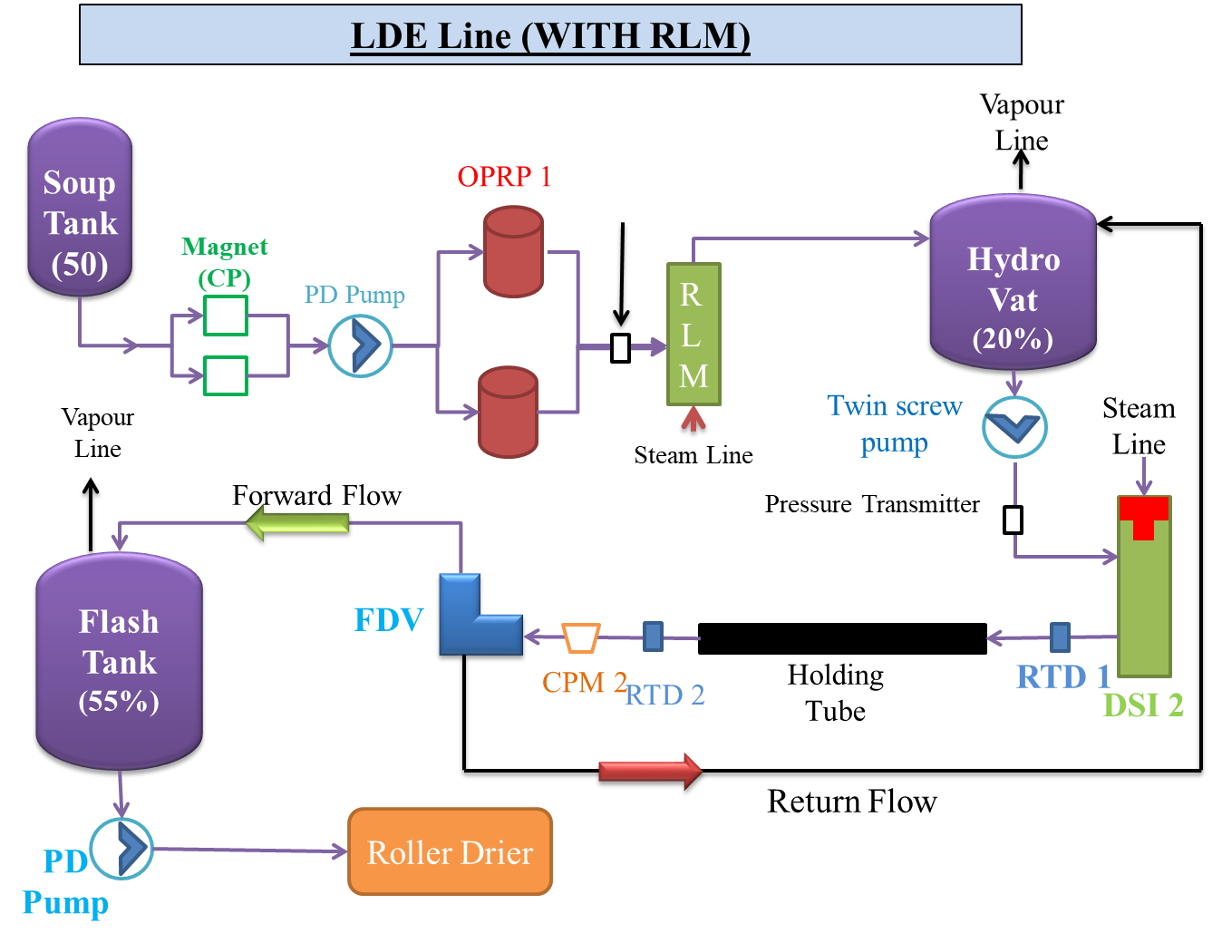

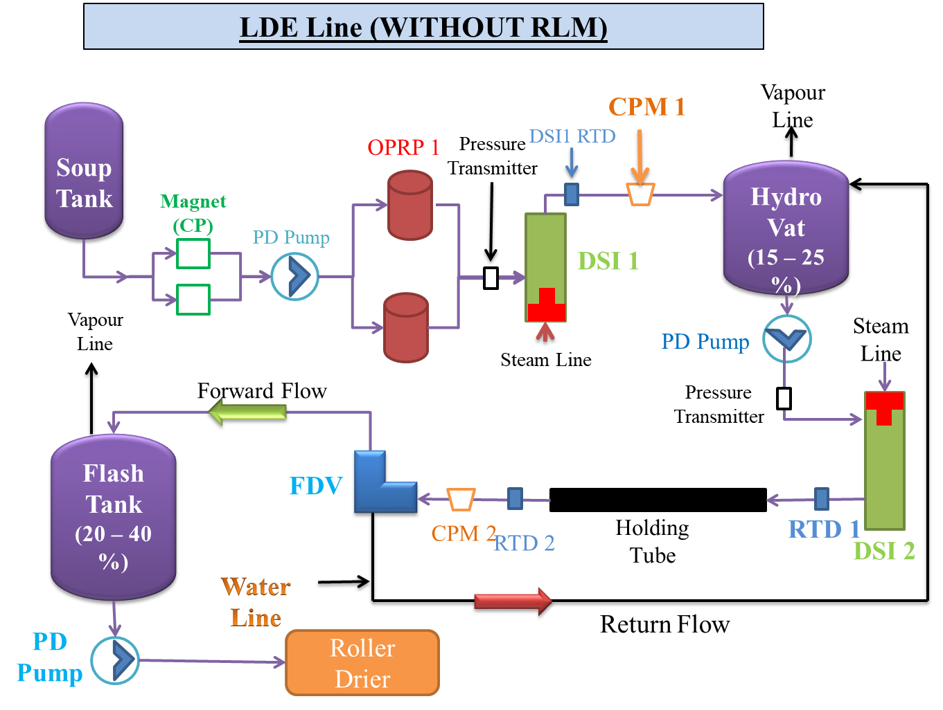

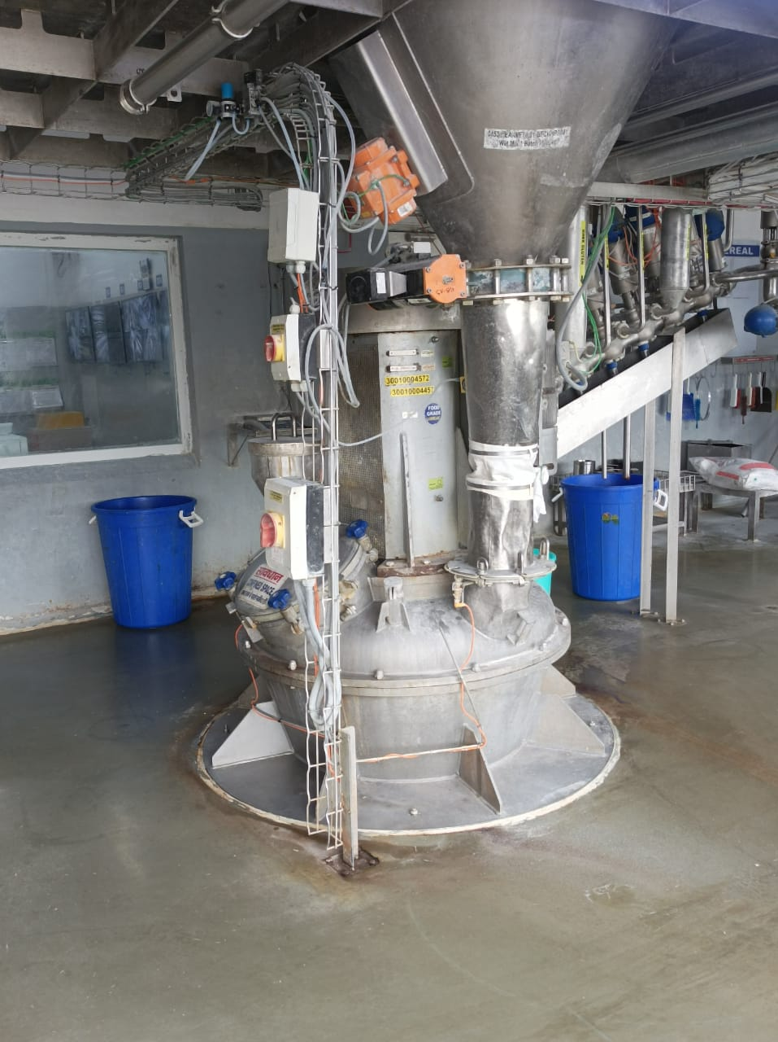

**General Points :-**

* Silos are provided with sensors, which tell the level of silos these sensors work on the principle of resonance frequency.
* Cloth collection are provided between silos and scale hopper.
* Only amount of water and enzyme can be adjusted in recipe.
* 80% of water is added initially 20% of water is added after addition of ingredients.
* Two batches of soup are consumed in pipeline from soup tank to roller dryer.
* Soup tanks are provided with level indicator sensor, which actually measures the pressure.
* Condition of soup filter is checked once in shift.
* Size of filter for apple tank, ghee tank, soyabean oil tank is 0.5mm.
* Hydrolysis of gluten side is done in RLM.
* Concentration of enzyme used is 2%.
* Hydrolysis of non-gluten side is done in Hydrolysis tank.
* Screws conveyer are provided for transferring material to scale hopper.
* Gain in Weight Feeder is provided except in case CaCO3, for CaCO3 LIWF is used.
* Only amount of water and enzyme can be adjusted in recipe.
* Amount of enzyme and water is adjusted for pap consistency
* CIP is fully automatic CIP stops when conductivity of returning solution reach to its set point.

**LIWF**

A loss in weight feeder is a gravimetric metering device that receives material from an upstream supply and accurately doses the material into a process at a predetermined feed rate, typically through a screw (auger or helix), twin screw, or vibratory tray. True to its “loss in weight” name, this feeder’s operation is regulated by the amount of live load that is lost as product is discharged. In order to do this effectively, the loss in weight feeder receives constant feedback from a sensitive weighing device, which ensures that the precise amount of material is delivered either continuously or in each batch.

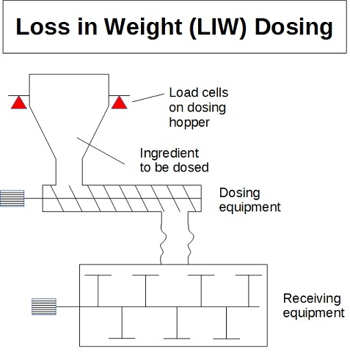

**GIWF**

**Gain in Weight Dosing Systems** are widely used to deliver bulk solids into a batch process. In a typical [batch feeding system](https://www.solidswiki.com/index.php/Batch_Feeders) an individual [volumetric feeders](https://www.solidswiki.com/index.php/Volumetric_Feeders), each one dedicated to a single raw material or active ingredient, are employed. Each [feeder](https://www.solidswiki.com/index.php/Feeders) delivers its material in sequence into a central collection [hopper](https://www.solidswiki.com/index.php/Hoppers), mounted on a [scale](https://www.solidswiki.com/index.php?title=Feeders_Scales&action=edit&redlink=1) or [load cells](https://www.solidswiki.com/index.php?title=Loadload_Cells&action=edit&redlink=1).

The weight of the receiving [vessel](https://www.solidswiki.com/index.php/Vessels) is monitored continuously as each ingredient is added in succession. Weight measurements are compared to the setpoint for each ingredient. When the required weight of an ingredient approaches its setpoint, the volumetric feeder goes into drible mode so to insure the feeder doesn't overshoot its target. When setpoint is reached, discharge from that feeder is stopped, and the next feeder is started. Once all the batch ingredients have been fed into the central gain-in-weight vessel, they are discharged into a mixer or blending system, or delivered directly to the next downstream step in the process.

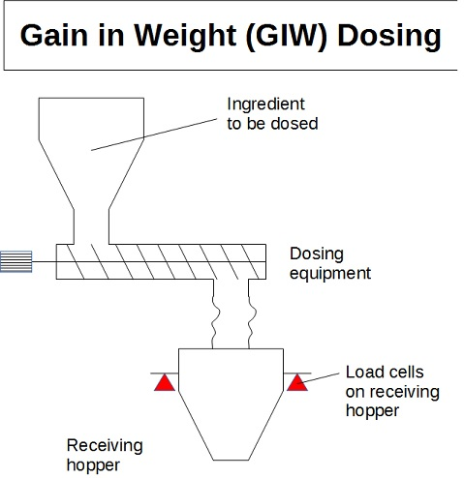

**Roller Drying:-**

Total of 8 RD are present and all of them are in working. RD (3, 4) is dedicated to non-gluten products while other RD are dedicated. Mono cylinder with satellite is used for drying of slurry. RD serves the purpose of drying, cooking and flavor generation in base powder. Scrapping of RD is done for cleaning. RD is provided with satellite roller, which help in sump formation. RD not only serves the purpose of drying it helps in flavor generation high temperature of RD.

Drying with the help of roller dryer is not simply a process of removal of water. In this process certain chemical reaction (Maillard Reaction) occurs which lead to formation of flavor forming compounds. Heating on roller dryer leads to the denaturation of gluten protein. Gluten protein is present in wheat flour. Denaturation of wheat protein leads to easy digestion of food. Gluten protein consists of Prolamines and Glutelins.

Roller dryer process:

**Key Learnings:-**

|  |  |  |  |
| --- | --- | --- | --- |
| **Process Parameter** | **Film Thickness** | **Film Porosity** | **Density(BP)** |
| Sump Level (Inc) | Inc | Dec | Inc |
| Satellite Speed (Inc) | Inc | Dec | Inc |
| Satellite Gap (Inc) | Inc | Dec | Inc |
| Drum Speed (Inc) | Dec | Inc | Dec |
| Soup TS (Inc) | Inc | Dec | Inc |

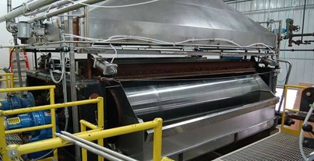

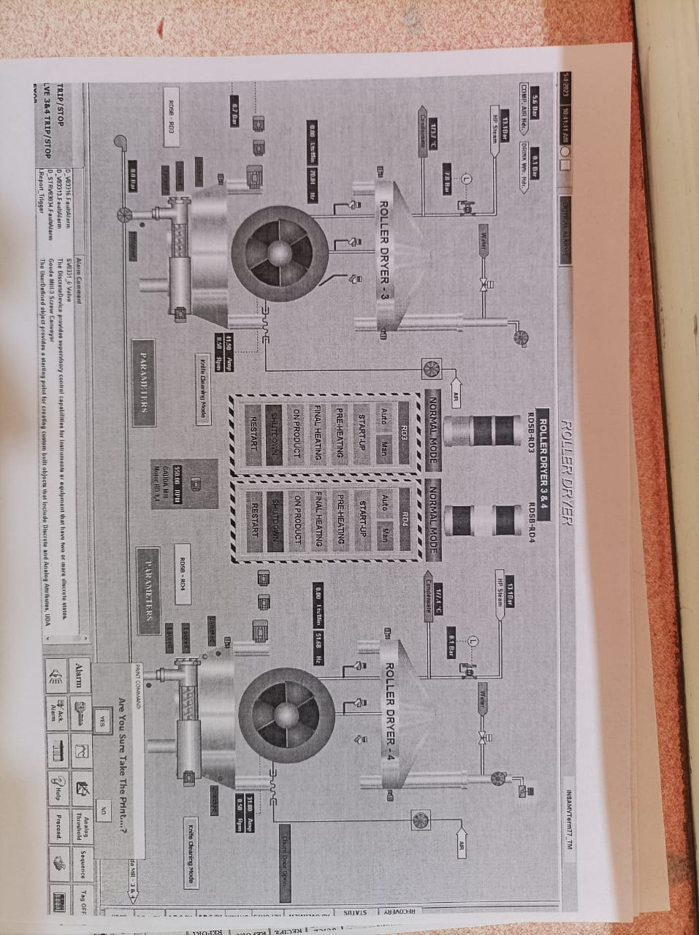

**Roller Drier Operation Review:-**

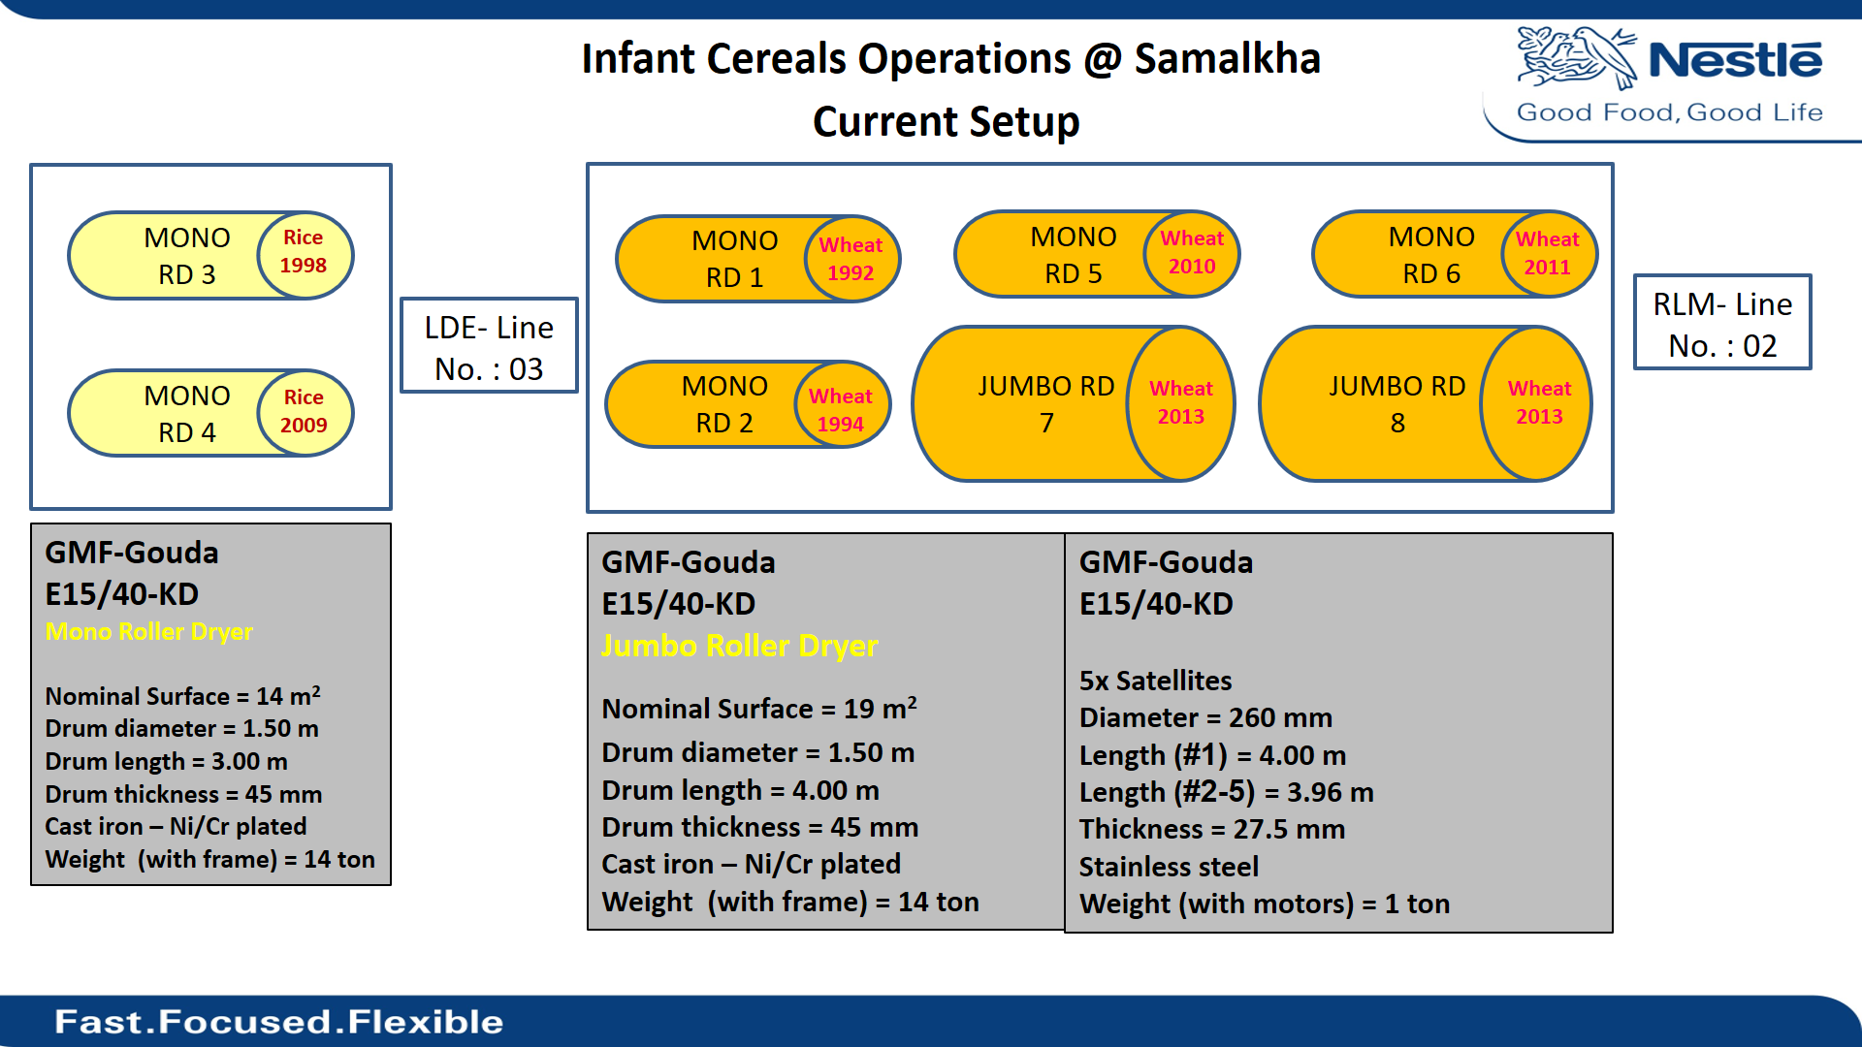

**Provision On Roller Drier:-**

1.Scrapper

2.Knife

3.Film Cooling Fan

4.Screw Conveyer

5.Side Scrapper

6.End Plate

7.Guide Plate

8.Hood

9.Temperature Sensor

10.Cooling Water in satellites

11.Pressure Gauge

**General Points:-**

* Temperature of roller drier is increased slowly to avoid damage to roller drier.
* It takes around 90 minutes to pre-heat the roller dryer to the temperature of about 130-135 C
* Cold water is supplied to satellite to avoid burning of soup.
* Satellite is provided for uniform distribution of soup on roller drier.
* Scrapper is provided for transfer of soup from one sump to another.
* Satellite farthest to knife is numbered 1.
* Satellite roller nearest to knife is numbered 5.
* Direction of rotation of satellite 5 is same as that of roller drier other satellites rotate in opposite direction.
* Cold air is supplied to film to avoid the reabsorption of moisture.
* RD cleaning (scraping) time is nearly 5 hours.
* Star Valve is checked for scratch, which can cause metal contamination.
* Space between side scrapper satellite rollers is 0.15mm, which is checked by using a metallic strip.
* Knife is cleaned after every run.
* Length of knife is 40 mm.
* Material used for the knife is Tungsten.
* Pressure of lube oil for roller dryer is 3kg/cm2.
* While removing knife screws of extreme points is opened at last.
* Satellite nearest to knife rotate in same direction as that of main roller.
* Max knife pressure that can be applied is 4 bar.

**Dry mix section**

This section is purely dedicated to mixing of base powder with the other ingredients like milk powder, vitamins and trace elements.

The films at the roller dryer are converted into the flakes. These flakes by the air pressure are transferred to the dry mix section where the air is removed from the line using cyclone silos and then are milled into the powder using Gouda mill. Here the reduction rollers reduce the particle size of the flakes to the desired size and the larger particles are removed in the oversize using sieves of different sizes as per the product.

The powder is then stored into the base powder silo along with the milk powder and sugar that is tipped from the milk powder dumping section.

The trace elements, iron and the vitamin premix are mixed and the preblend is then tipped.

Crunchy is also added into the final product in the same way.

All the material is then transferred to the hopper using screw conveyor.

The material from the hopper is received by the mixer. The product is mixed at about 50 RPM for 4 minutes. The mixed product is then filled in the tote bins.

**General Points:-**

* LIWF is used for dosing of preblend &vitamins.
* Pressure difference against filter of cyclone is 0.5 inch/water.
* Pressure difference against MP silo is 10mm/water.
* Texture of final product depend on the size of sieve used.
* Oversize of Gouda mill collected in a liner.
* Amount of over sieve collected depends on the open area.
* Milling gives a homogenous product.
* By increasing RPM bulk density of final product increase.
* Pressure difference of 0.5 inch of water in maintained against these silos for proper working of conveying system.

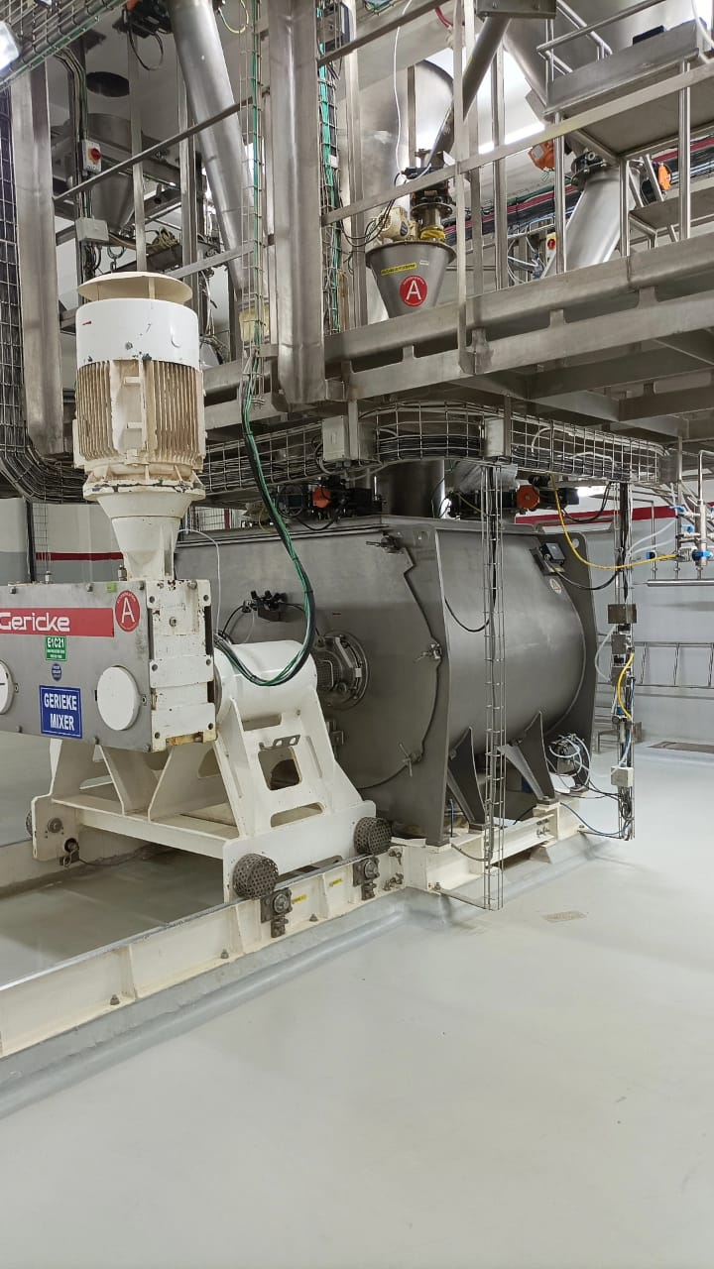

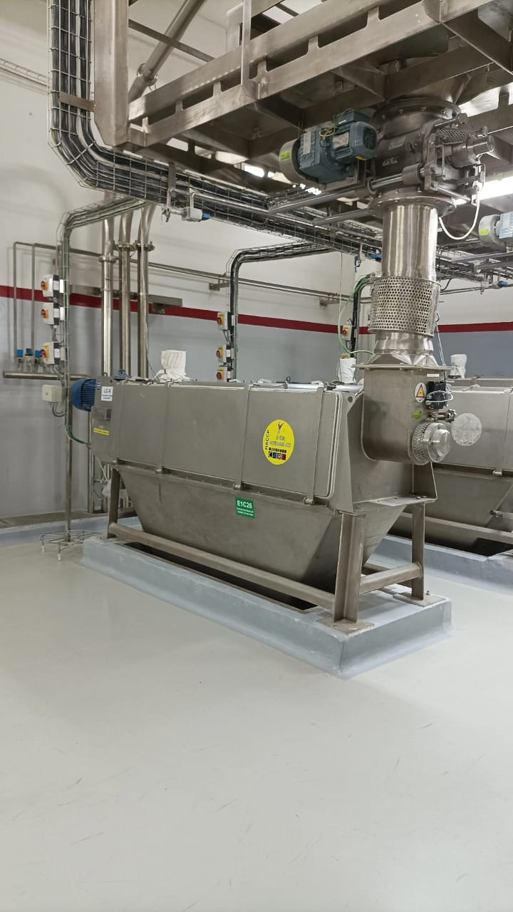

**Packing of final product**

At the tote bin stations, the bins are tilted and the product flows out of the bin into the hopper. Now, via Vibra sifter the product passes through the metal detector to reach the mini hopper and is transferred to auger trough. There the product is filled into the pouches. This is done using vertical form filling and sealing machine. The pouches undergo all necessary QMS checks and are transferred onto the Autocartoner or the Langen for secondary packaging of the product(duplex by bag in box method). It includes duplex formation, scoop insertion in the duplex, gluing of the duplex and formation of the final shippers.

**Vertical form filling and sealing machine**

Vertical packaging machines use a single sheet of film material rolled around a core, usually referred to as rollstock. The continuous length of packaging material is referred to as the film web. The roll of film is placed on a spindle assembly at the rear of the machine. During operation, the film is pulled off the roll by film transport belts, which are positioned to the side of the forming tube which is located at the front of the machine.

During unwinding, the film is unwound from the roll and passes over a dancer arm which is a weighted pivot arm located at the rear of the VFFS packaging machine. The arm incorporates a series of rollers. As the film transports, the arm moves up and down to keep the film under tension. This ensures that the film will not wander from side to side as it is moving. The film then travels through the printing unit. The printer used is

Once the film has passed under the printer, it travels past the registration photo-eye. The registration photo eye [detects the registration mark on printed film](https://vikingmasek.com/packaging-machine-resources/packaging-machine-blog/video-vffs-machine-maintenance-how-set-film-registration-photo-eye-sensor) and in turn, controls the pull-down belts in contact with the film at the forming tube. The [registration photo-eye](https://vikingmasek.com/packaging-machine-resources/packaging-machine-blog/video-vffs-machine-maintenance-how-set-film-registration-photo-eye-sensor) keeps the film positioned correctly so the film will be cut in the appropriate spot. Next, the film travels past [film tracking sensors](https://vikingmasek.com/packaging-machine-resources/packaging-machine-blog/video-vffs-machine-maintenance-how-set-automatic-film-tracking) that detect the position of the film as it's traveling through the packaging machine

The film enters a forming tube assembly. As it crests the shoulder (collar) on the forming tube, it is folded around the tube so that the end result is a length of film with the two outer edges of the film overlapping each other. This is the beginning of the bag forming process.

**General Points:-**

● Auger is provided with servomotor due to reason of quick action.

● Flexible bags are provided to avoid the seal damage. Its act as shock absorber.

● Exhaust system is provided for the removal of fine particles, which effect the efficiency of sealing.

● Printing on pouch is done with TTO.

● Max Oxygen percentage vary from product to product.

● For seal, testing Rhodamide dye is used for khichdi variant.

● For printing of duplex laser printer is used, it burns the upper layer of the duplex.

**Packaging defects**

Defect seal leakage

Laminate puncture

Code cutting or missing

Joint tape

Wrinkled pouch

Less weight

Overlapping

Improper gassing

Pinhole defect

Deep lining effect

**Autocartoner**

**Cleaning In Place:**

CIP is the process in which cleaning of instruments and lines occurs without dismantling the line. CIP saves lot of time of dismantling of equipment. In CIP in-line mixing of water & (caustic+acid) occurs to adjust the concentration. Conductivity of returning solution is checked by sensors to check completion of CIP.

Tanks are provided with rotating disks for effective cleaning. For the cleaning of silos(Raw material) CIP is not used air pressure is used to clean the silos. Brushes are provided to clean the silos of raw material.

Pre Rinse is provided for the removal soup . Caustic is provided for the removal of residues of residues of fat. Intermediate rinse is provided for the removal of caustic because direct rinsing of acid after caustic lead to strong exothermic reaction between them. Acid rinse is provided for the removal of mineral deposits. Finally fresh water rinse is provided for the removal of mineral deposits.

**CIP have following steps:-**

1. Pre-Rinse reused water at ambient temperature for 10 min.
2. Caustic rinse (NaOH 1.5-2.0% 70-90°C for 20-60 min).
3. Intermediate Rinse (Reused water) 5 min.
4. Acid Cleaning (0.5-1.0%) 60-80°C 20 min. Final Rinse (fresh water) ambient temperature.

**CIP is divided into circuits for fast and efficient cleaning:-**

**CIP Centre-Group B**



**CIP Circuit Group-C**



**CIP Centre-Group A**

|  |  |
| --- | --- |
| Circuit | Equipment |
| CIP Ckt- (A) | Apple Juice Tank Glu |
| CIP Ckt- (A) | Apple Juice Tank-Ngl |
| CIP Ckt- (A) | Orange Juice Tank Glu |
| CIP Ckt- (A) | Orange Juice Tank-Ngl |
| CIP Ckt- (A) | Juice Transfer Line to Mixer-Glu |
| CIP Ckt- (A) | Juice Transfer Line to Mixer-Ngl |
| CIP Ckt- (A) | Papenmier Wet Mixer with Soup Bal tank-Glu |
| CIP Ckt- (A) | Papenmier Wet Mixer Outlet Line-Glu |
| CIP Ckt- (A) | Papenmier Wet Mixer with Soup Bal Tank-Ngl |
| CIP Ckt- (A) | Papenmier Wet Mixer Outlet Line-Ngl |

**6 T’s of CIP**

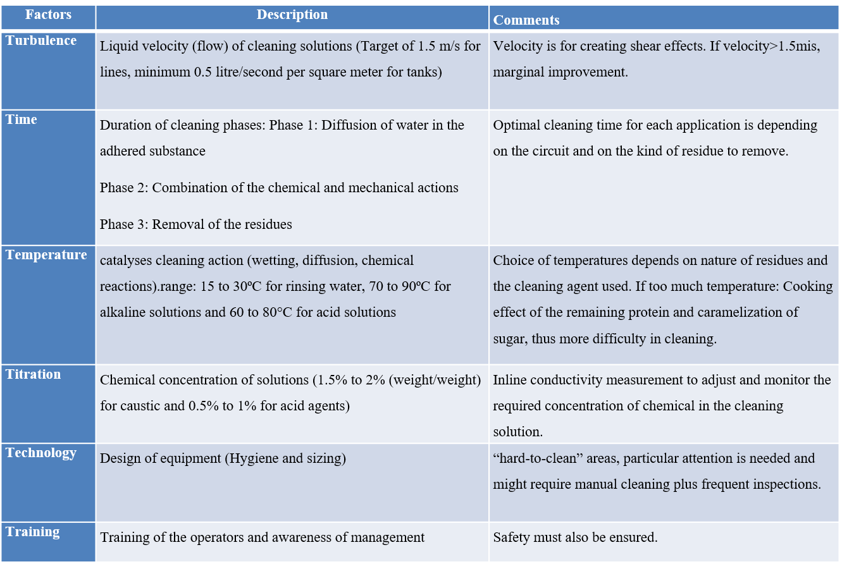

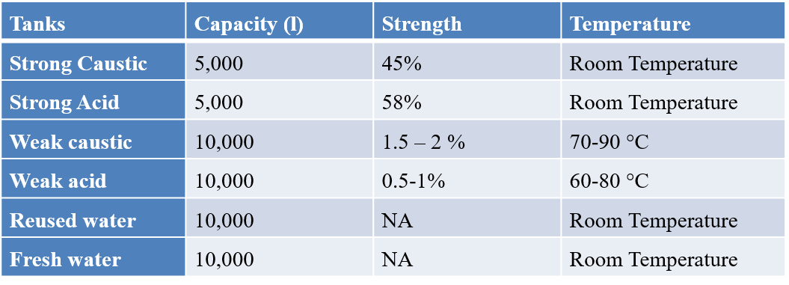

**Rework**

it is the action performed upon the non-conforming products, that when completed, makes it conform to its requirements.

Here in nestle it is classified into 2 main categories

* Dry rework: used as such in the final product in definite quantity so as to not change the recipe balance of the final product.
* Wet rework: this is to be reprocessed just like the raw material to make the final product.

There is another type called Recycle rework that is directly added to the final product of same PO.

Sources of rework:

Filling and packing

* Product changeover
* Breakdown
* Oversize
* Leak pouch
* Metal detector check
* X-Ray check

Roller dryer

* Product changeover
* Run-end

Dry mix section

* Oversize from
* Product changeover
* Run-end

**General points:**

* Oxygen% of the rework bags is to be less than 5%.
* Shelf life Cerelac rework is 90 days whereas of Nestum products is 75 days.

CCPs and OPRPs in each section

|  |  |  |  |  |
| --- | --- | --- | --- | --- |
|  |  |  |  |  |
| CCP 1 | Heat treatment | Application and control of holding time and temperature | LDE1:122C/ 7.3 sec  LDE2:121C/9.4 sec  LDE3:117C/23.5 sec |  |
| CCP 2 | Metal detector | Ferrous, non-ferrous, stainless steel metal pieces |  |  |
| CCP 3 | Preblend Dosing | Preblend dosing ratio to be maintained in auto. |  |  |

|  |  |  |  |
| --- | --- | --- | --- |
|  |  |  |  |
| **OPRP 1** | **Soup Filtration** | Foreign body | Filtration of soup through 2mm stainless steel duplex filter |
| OPRP 2 | Sieving | Choking hazards associated with tipping operations  Hard particles generated during DSI system | Vibratory sieve 5mm or 15mm as per product specification. |
| OPRP 3 | Artwork of duplex/carton/printed laminate | Missing or unreadable consumer information | Checking of artwork |
| OPRP 5 |  |  |  |
| OPRP 6 | Bar code reader for duplex carton and for printed laminate | Food allergen: gluten | Continuous passing of packs against the bar code reader |
| OPRP 7(A)  OPRP 7(B) | Skim milk powder  Rice crunchies flour extruded Ragi | Aflatoxin m1 residue of veterinary drugs  Gluten allergen | Positive release on the basis of analysis results complying with RM specs  Each lot of rice crunchies and extruded ragi is released only after the gluten results. |
| OPRP 8 | Pre-weighing | Overdose of vitamins and trace elements | Balance check with standard weight  Batch quantities of all preblend ingredients displayed at the location of weighing |
| OPRP 9 | Premixing | Overdose of vitamins and trace elements (due to human mistake during weighing or tipping of material) | Positive release of preblend |
| OPRP 10 | Dipotassium diphosphate, salt, premix electrolytic iron, calcium carbonate etc. | Wrong identity | Identity check and positive release acc. To RM specs |
| OPRP 11 | Gouda mill sieve | Choking hazard  Hard particles generated in DSI system or drying operation. | Sieve  2mm  Or as per product specification |
| OPRP 12 | X-Ray System | Foreign bodies | Continuous X-Ray monitoring |

My responsibilities:

PROJECT TITLE:

TPM and its pillars

OBJECTIVE:

To study about TPM and how is it important TPM (Total Productive Management) TPM or Total Productive Maintenance is the process of using machines, equipment’s, employees and supporting processes to maintain and improve the integrity of the product and quality of system. Put simply, it's the process of getting employees involved in maintaining their own equipment while emphasizing proactive and preventive maintenance techniques. Total productive maintenance strives for perfect production. That is No breakdowns, No stops or running slowly, No defects, No accidents. Since the goal of total productive maintenance is to improve productivity by reducing downtime, implementing a TPM program can greatly impact your overall equipment effectiveness (OEE) over time. To do this, preventive maintenance should always be at the forefront of everyone's mind. For example, running machines with the mindset of "we'll fix it when it breaks" is not an option with total productive maintenance. A TPM program helps get rid of this mindset and turns it into one of putting machinery at the c

Autonomous maintenance: Autonomous maintenance means ensuring your operators are fully trained on routine maintenance like cleaning, lubricating and inspecting, as well as placing that responsibility solely in their hands. This gives machine operators a feeling of ownership of their equipment and increases their knowledge of the particular piece of equipment. It also guarantees the machinery is always clean and lubricated, helps identify issues before they become failures, and frees up maintenance staff for higher-level tasks.

Focused improvement: Focused improvement is based around the Japanese term "kaizen," meaning "improvement." In manufacturing, kaizen requires improving functions and processes continually. Focused improvement looks at the process as a whole and brainstorms idea for how to improve it. Getting small teams in the mindset of proactively working together to implement regular, incremental improvements to processes pertaining to equipment operation is key for TPM.

Planned maintenance: Planned maintenance involves studying metrics like failure rates and historical downtime and then scheduling maintenance tasks based around these predicted or measured failure rates or downtime periods.

Quality maintenance: All the maintenance planning and strategizing in the world is all for naught if the quality of the maintenance being performed is inadequate. The quality maintenance pillar focuses on working design error detection and prevention into the production process. It does this by using (specifically the "5 Whys") to identify and eliminate recurring sources of defects. Early equipment management: The TPM pillar of early equipment management takes the practical knowledge and overall understanding of manufacturing equipment acquired through total productive maintenance and uses it to improve the design of new equipment.

Training and education: Lack of knowledge about equipment can derail a TPM program. Training and education applies to operators, managers and maintenance personnel. They are intended to ensure everyone is on the same page with the TPM process and to address any knowledge gaps so TPM goals are achievable. Safety, health and environment: Maintaining a safe working environment means employees can perform their tasks in a safe place without health risks. It's important to produce an environment that makes production more efficient, but it should not be at the risk of an employee's safety and health.

TPM in administration: A good TPM program is only as good as the sum of its parts. This means supporting production by improving things like order processing, procurement and scheduling.

**Loss in spoons**

Reduce the no. of spoons wasted during the packaging process.

Factors responsible for spoon wastage

Root cause analysis done using 5 why method.

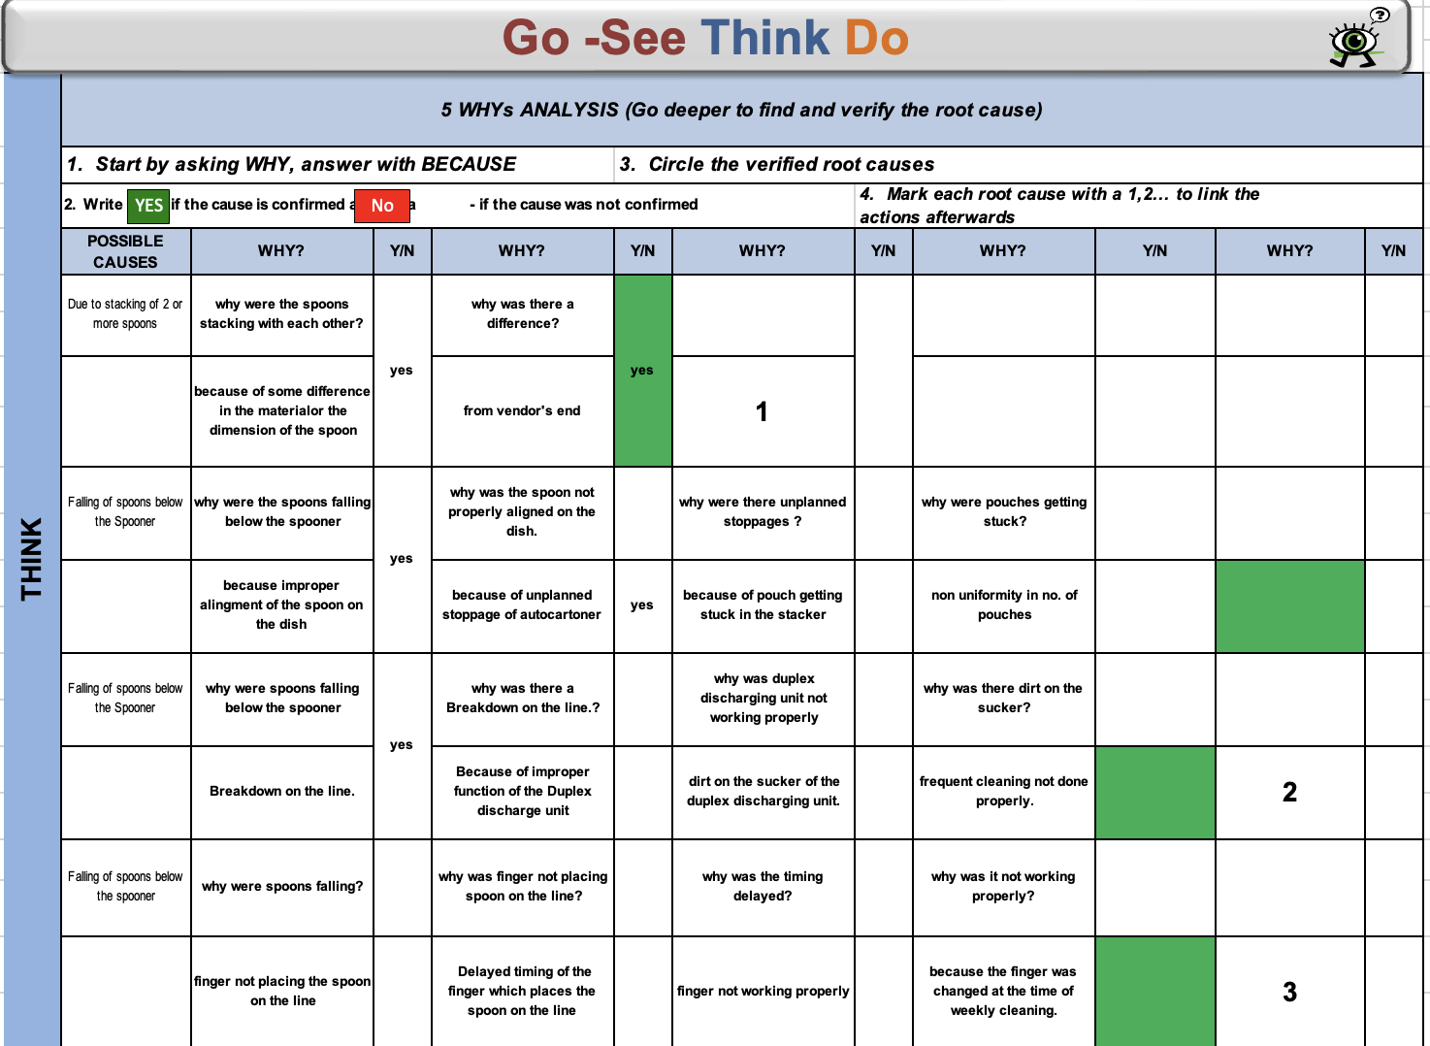

Actions Taken

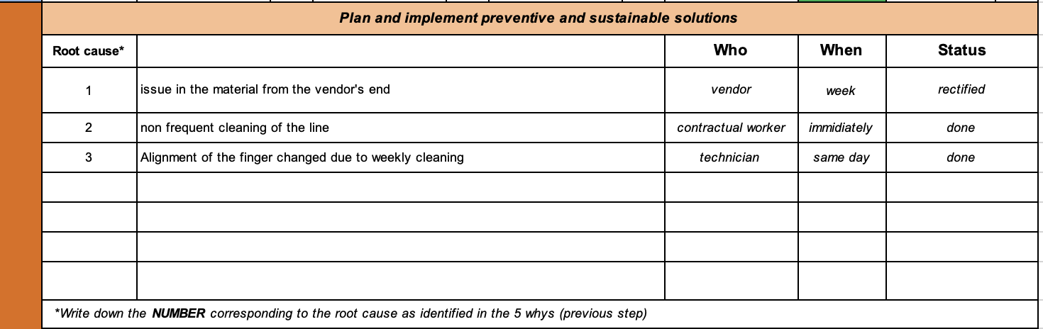

**GSTD done and attached along with the report**

On the basis of my current observations, I would like to suggest to reuse the spoons that fall

off the line. This can be done in various ways but the best suited way for the reuse is pre-

wash and then UV light sterilization.

The first step of this procedure needs to be proper handling of the spoons i.e., separation of the spoons that are rejected and the spoons that fall on the ground.

Then the required pre-washing with water or detergent can be done to remove the dirt

Then to kill the microbial load, disinfection using UV light of 254nm needs to be done.

The time of the exposure depends upon the geometry and the placement (the distance between two spoons).

Mapping of Rework Generation in filling and packing area

To reduce the rework generation in filling and packing area in infant cereal.

Reasons of rework generation

Leak pouches

MD and X-ray rejected pouches

Product changeover

Blockage